
SIMATS ENGINEERING
Saveetha Institute of Medical and Technical Sciences
Chennai-602105
FINANCIAL PORTFOLIO MANAGEMENT AND RISK ANALYSIS USING POLICY GRADIENT REINFORCEMENT LEARNING
A CAPSTONE PROJECT REPORT
A Capstone Project Report submitted in partial fulfilment of the requirements
for the Course of
MLA0301- Reinforcement Learning
to the award of the degree of
BACHELOR OF ENGINEERING / BACHELOR OF TECHNOLOGY
IN
COMPUTER SCIENCE AND ENGINEERING

Submitted by
T Bhanu Teja(192472259)
Under the Supervision of
Dr. G. A. Senthil Kumar

SEPTEMBER 2026

BONAFIDE CERTIFICATE

This is to certify that the Capstone Project entitled “Financial Portfolio Management and Risk Analysis Using Policy Gradient Reinforcement Learning” has been carried out by T Bhanu Teja(192472259) under the supervision of Dr. G. A. Senthil and is submitted in partial fulfilment of the requirements for the current semester of the B.E Computer Science and Engineering at Saveetha Institute of Medical and Technical Sciences, Chennai.

COURSE COORDINATOR COURSE FACULTY

Dr. G. A. Senthil Dr. G. A. Senthil
Professor Professor
Department of Cloud Computing Department of Cloud Computing
SIMATS Engineering SIMATS Engineering,
SIMATS, Chennai – 602105. SIMATS, Chennai – 602105.

DECLARATION
I, T Bhanu Teja(192472259) of the Artificial Intelligence ,SIMATS Engineering, Saveetha Institute of Medical and Technical Sciences, Chennai, hereby declare that the Capstone Project Work entitled “Financial Portfolio Management and Risk Analysis Using Policy Gradient Reinforcement Learning” is the result of our own bonafide efforts. To the best of our knowledge, the work presented herein is original, accurate, and has been carried out in accordance with the principles of engineering ethics and academic integrity. All sources, references, data, software, datasets, computational resources, and AI-assisted tools used during the project shall be appropriately acknowledged. We further declare that no experimental result, performance value, dataset statistic, or financial outcome has been fabricated, falsified, or manipulated.

Place: Simats, Chennai
Date : 07-09-26

Signature of the Students with Names
T Bhanu Teja

Individual Contribution Statement
(Mandatory for all team projects)
Student Name / Register No. | Specific Responsibilities | Design & Development | Testing & Analysis | Report Contribution | Approx. Contribution (%)
E Teja Vardhan(192425297) | User profile creation; portfolio setup; asset allocation; investment preference preparation | Designed and developed the User & Portfolio Management module | Tested portfolio creation, asset allocation, and user data validation | Contributed to user management, portfolio management, and related documentation | 33%
T Bhanu Teja(192472259) | Market data collection; data preprocessing; return calculation; volatility and risk analysis | Designed and developed the Market Data & Risk Analysis module | Tested market data quality, risk calculations, volatility, and portfolio risk measures | Contributed to market data preprocessing, risk analysis, testing, and documentation | 34%
A Shiva Shankar(192425174) | Portfolio state and action preparation; reward calculation; policy gradient model development; investment decision generation | Designed and developed the Policy Gradient Reinforcement Learning & Decision Support module | Tested the reinforcement learning model, investment decisions, portfolio performance, and risk-adjusted results | Contributed to reinforcement learning implementation, performance evaluation, and final report preparation | 33%
TOTAL |  |  |  |  | 100%

The supplied project information identifies three functional modules but does not identify the actual number of students or their individual work. Therefore, names, responsibilities and percentages are intentionally left for evidence-based completion.

ABSTRACT
Financial portfolio management requires repeated decisions under uncertainty, where an allocation that performs well in one market condition may expose the portfolio to undesirable risk in another. This project proposes a reinforcement-learning-based decision-support framework for portfolio management and risk analysis using a policy-gradient approach. The system is organised into three functional modules: User & Portfolio Management; Market Data & Risk Analysis; and Policy Gradient Reinforcement Learning & Decision Support. Within the proposed RL formulation, the environment represents the evolving portfolio and market condition, the state represents relevant market, portfolio and risk information, and the action represents a portfolio allocation decision. The policy produces a probability distribution over feasible actions, while the reward is intended to combine portfolio performance with risk considerations so that the learning objective does not rely on return alone. The policy-gradient mechanism updates policy parameters in the direction that improves expected cumulative reward. A complete experimental evaluation requires the project dataset, preprocessing details, implementation configuration and recorded training/test results; these were not supplied with the current project description. Consequently, this report does not claim numerical performance, profitability, Sharpe ratio, maximum drawdown, convergence, or superiority over a benchmark. The proposed design instead establishes the engineering formulation, implementation structure, evaluation plan, responsible-use constraints and evidence requirements needed for a valid RL portfolio-management prototype. The system is intended as decision support rather than a guarantee of financial returns, and any future deployment should account for transaction costs, market regime changes, data leakage, overfitting and human oversight.
The policy produces a probability distribution over feasible actions, while the reward is intended to combine portfolio performance with risk considerations so that the learning objective does not rely on return alone. The policy-gradient mechanism updates policy parameters in the direction that improves expected cumulative reward. A complete experimental evaluation requires the project dataset, preprocessing details, implementation configuration and recorded training/test results; these were not supplied with the current project description. Consequently, this report does not claim numerical performance, profitability, Sharpe ratio, maximum drawdown, convergence, or superiority over a benchmark. The proposed design instead establishes the engineering formulation, implementation structure, evaluation plan, responsible-use constraints and evidence requirements needed for a valid RL portfolio-management prototype. The system is intended as decision support rather than a guarantee of financial returns, and any future deployment should account for transaction costs, market regime changes, data leakage, overfitting and human oversight.

Keywords
Financial Portfolio Management; Risk Analysis; Reinforcement Learning; Policy Gradient; Portfolio Allocation; Decision Support

TABLE OF CONTENTS
Sl. No. | Title | Page No.
i | CERTIFICATE FROM THE SUPERVISOR | ii
ii | DECLARATION BY THE CANDIDATE | iii
iii | INDIVIDUAL CONTRIBUTION STATEMENT | iv
iv | ABSTRACT | v
v | LIST OF FIGURES | vi
vi | LIST OF TABLES | vii
vii | LIST OF ABBREVIATIONS / SYMBOLS | viii
1 | CHAPTER 1: Introduction and Engineering Problem | 10
2 | CHAPTER 2: Literature Review and Existing Solutions | 12
3 | CHAPTER 3: Engineering Design & Trade-offs, Sustainability, Ethics, Safety, Risk & Security | 14
4 | CHAPTER 4: Implementation, Testing & Results, Project Management | 20
5 | CHAPTER 5: Conclusion, Future Work and Reflection | 25
 | REFERENCES | 26
 | APPENDICES | 27

Page numbers above are placeholders because final pagination depends on the completed student-specific material, figures, tables and appendices.

LIST OF FIGURES
Figure No. | Figure Name | Page No.
Figure 1 | Proposed Portfolio Management & Risk Analysis Architecture | 17
Figure 2 | Policy Gradient Training Loop | 19
Figure 3 | Conceptual Policy Network / Action-Distribution Flow | 21
Figure 4 | Agent–Environment Interaction | 22
Figure 5 | State–Action–Reward Representation | 24
Figure 6 | Dataset / Market Data Processing Pipeline | 27
Figure 7 | Training Reward Curve (actual experimental data required) | 30
Figure 8 | Portfolio Performance Comparison (actual experimental data required) | 32

LIST OF TABLES
Table No. | Table Name | Page No.
Table 1 | Project Modules | 13
Table 2 | Functional Requirements | 14
Table 3 | Non-Functional Requirements | 14
Table 4 | RL State Variables | 15
Table 5 | Action Space | 15
Table 6 | Reward Components | 16
Table 7 | Policy Gradient Parameters | 17
Table 8 | Alternative Approaches | 17
Table 9 | Test Plan and Verification | 18
Table 10 | Experimental Results | 20
Table 11 | Failure Analysis | 22
Table 12 | Risk Register | 24
Table 13 | Objective Achievement Mapping | 25
Table 14 | Project Roles and Budget | 26

LIST OF ABBREVIATIONS / SYMBOLS
Symbol | Description | Unit
RL | Reinforcement Learning | —
MDP | Markov Decision Process | —
PG | Policy Gradient | —
ROI | Return on Investment | %
VaR | Value at Risk | currency / %
CVaR | Conditional Value at Risk | currency / %
SR | Sharpe Ratio | —
MDD | Maximum Drawdown | %
s | State | —
a | Action | —
r | Reward | —
πθ | Policy parameterized by θ | —
γ | Discount factor | —
G_t | Return from time t | reward units
θ | Policy parameters | —

CHAPTER 1
INTRODUCTION AND ENGINEERING PROBLEM

1.1 Background
Portfolio management is a sequential decision problem. At each decision point, an investor or portfolio manager observes information about market conditions and the current portfolio, chooses an allocation or rebalancing action, and then experiences a financial outcome influenced by subsequent market movements. This repeated interaction makes portfolio management naturally expressible as a reinforcement learning problem, provided that the state, action, transition and reward definitions are carefully constructed.
The proposed project applies policy-gradient reinforcement learning to financial portfolio management and risk analysis. The key engineering objective is not simply to maximise historical return, but to construct a decision-support process in which portfolio performance and risk are evaluated together. The project is organised into three modules: User & Portfolio Management; Market Data & Risk Analysis; and Policy Gradient Reinforcement Learning & Decision Support.

1.2 Need for the System
Traditional portfolio allocation approaches commonly depend on fixed rules, optimisation assumptions, or estimates derived from historical data. Financial markets are non-stationary and contain uncertainty, so a decision rule that is appropriate under one regime may not remain appropriate under another. A sequential learning formulation can explicitly model repeated decisions and feedback, while a risk-aware reward can discourage decisions that obtain return by taking disproportionate risk.
The proposed system is intended for users who need structured portfolio allocation and risk information. It should be interpreted as decision support rather than autonomous financial advice or a guarantee of returns. The engineering significance lies in integrating market information, portfolio state, risk measures and policy-based decisions within one repeatable computational framework.

1.3 Problem Statement
The project addresses the engineering problem of designing a reinforcement-learning decision-support system that receives portfolio and market observations, represents them as a state, selects an allocation action through a parameterised policy, applies the action to a portfolio environment, evaluates the resulting return and risk, and uses the resulting reward to update the policy. The system must balance performance, risk, feasibility and computational considerations while avoiding data leakage and unsupported claims of financial performance.
INPUT → STATE / OBSERVATION → POLICY-GRADIENT AGENT → PORTFOLIO ACTION → ENVIRONMENT RESPONSE → REWARD → POLICY UPDATE → IMPROVED DECISION

1.4 Project Aim
To design and develop a policy-gradient reinforcement learning framework for financial portfolio management and risk analysis that supports risk-aware sequential allocation decisions.

1.5 Project Objectives
- To define a portfolio-management environment that represents market, portfolio and risk information as an RL state.
- To design a feasible action representation for portfolio allocation or rebalancing decisions.
- To formulate a reward function that reflects portfolio performance together with relevant risk considerations.
- To implement the selected policy-gradient learning mechanism and its policy-update procedure.
- To establish a reproducible training and evaluation procedure using only verified project data and configurations.
- To evaluate the trained policy using appropriate return and risk metrics such as cumulative return, Sharpe ratio and maximum drawdown when the required experimental data are available.
- To provide a decision-support output that communicates portfolio actions and risk information without representing historical back-testing as a guarantee of future performance.

1.6 Scope
Included: portfolio/user information, market-data and risk-analysis processing, RL state/action/reward formulation, policy-gradient learning, portfolio decision support, testing design, and performance/risk evaluation. Excluded unless supplied separately: live brokerage execution, guaranteed investment advice, real-money trading, undisclosed datasets, and unverified claims about profitability. The report assumes that market observations and portfolio constraints can be represented numerically and that the RL environment can evaluate the consequences of an action.

1.7 Expected Engineering Outcome
The intended outcome is a documented software prototype or computational framework that integrates portfolio management, market/risk analysis and policy-gradient reinforcement learning. The expected output is a risk-aware portfolio decision and supporting metrics, subject to the actual implementation and experimental evidence supplied by the project team.

CHAPTER 2
LITERATURE REVIEW AND EXISTING SOLUTIONS

2.1 Review Method
The review is structured around four technical areas: reinforcement learning and Markov decision processes; policy-gradient optimisation; portfolio optimisation and risk measurement; and responsible evaluation of financial machine-learning systems. Because no literature list was supplied with the project materials, the references included at the end of this draft should be verified against the sources actually used by the project team before submission.

2.2 Review of Existing Work
Reinforcement learning models sequential decision-making through interaction between an agent and an environment. A policy maps states or observations to actions, and learning seeks to improve expected cumulative reward. Policy-gradient methods directly optimise policy parameters rather than maintaining a discrete action-value table. This makes them attractive when the portfolio action is represented continuously, for example through allocation weights subject to feasibility constraints.
Financial portfolio optimisation adds domain-specific difficulties. Returns are noisy, distributions can change over time, transaction costs can materially affect rebalancing decisions, and risk cannot be represented by return alone. Consequently, a useful RL portfolio system must distinguish training data from evaluation data and must test whether the policy remains meaningful outside the data used to optimise it.
For risk analysis, metrics such as volatility, Sharpe ratio, maximum drawdown, Value at Risk and Conditional Value at Risk may be considered where appropriate to the actual project. Their exact implementation, window sizes and confidence levels must be taken from the source code or experiment configuration rather than assumed.

2.3 Comparative Analysis
The selected policy-gradient approach is compared below with relevant families. This is a theoretical engineering comparison; it does not claim that the alternatives were implemented in the supplied materials.
Approach | Learning approach | Action handling | Training complexity | Advantages | Limitations | Relevance
Policy Gradient | Direct policy optimisation | Continuous or stochastic actions can be represented naturally | Moderate to high | Directly optimises policy; suitable for stochastic decisions | Gradient variance; sensitive to reward scaling | Selected approach
Q-Learning | Value-based TD learning | Primarily discrete action spaces in basic form | Low to moderate | Simple conceptual update; effective for small discrete spaces | Continuous portfolio weights require adaptation | Alternative
DQN | Deep value-based learning | Discrete actions | High | Handles large state spaces better than tabular Q-learning | Discrete action design can become restrictive for allocation | Alternative
Actor–Critic | Policy + value estimation | Continuous/stochastic actions supported | High | Can reduce policy-gradient variance | More components and tuning requirements | Relevant extension
PPO | Clipped policy optimisation | Continuous/stochastic actions supported | High | Improved stability in many RL settings | More hyperparameters and implementation complexity | Potential future comparison

2.4 Research / Engineering Gap
The central engineering gap for this project is the integration of a policy-gradient decision mechanism with explicit portfolio and risk representations under realistic financial constraints. A technically valid prototype must also demonstrate that its evaluation is separated from training and that financial metrics are interpreted with uncertainty rather than as guaranteed outcomes.

2.5 Proposed Contribution
The proposed contribution is an integrated three-module framework that connects user and portfolio information, market/risk analysis, and policy-gradient reinforcement learning into a single decision-support workflow. The contribution is specifically framed as a computational prototype and evaluation framework; numerical claims about performance remain dependent on the missing implementation and experimental evidence.

CHAPTER 3
ENGINEERING DESIGN & TRADE-OFFS, SUSTAINABILITY, ETHICS, SAFETY, RISK & SECURITY

3.1 Requirements

Stakeholder / User Requirements
Stakeholder | Requirement
Portfolio user | View portfolio composition and relevant portfolio information.
Portfolio user | Receive an allocation/rebalancing decision with supporting risk information.
Project evaluator | Verify that state, action, reward and policy update are implemented consistently.
Developer / maintainer | Use reproducible inputs and configurations for training and evaluation.

Functional & Non-Functional Requirements
Requirement Type | Requirement | Measurable Target
Functional | Accept portfolio and market observations | Inputs documented and validated
Functional | Generate RL state | State variables explicitly defined
Functional | Select portfolio action | Action mapping documented and constraint-checked
Functional | Calculate reward | Reward equation and components documented
Functional | Train policy | Training loop executes without undefined steps
Functional | Evaluate policy | Return and risk metrics computed where data exist
Non-Functional | Reproducibility | Random seeds/configuration recorded when used
Non-Functional | Reliability | Invalid allocations/data are detected
Non-Functional | Maintainability | Modules separated by responsibility
Non-Functional | Security | User/data inputs validated and protected

3.2 Constraints & Applicable Standards
Only constraints demonstrably relevant to a financial decision-support prototype are included. The exact institutional standards used by the project team were not supplied.
Standard / Code / Principle | Requirement | How Applied in This Project
Academic integrity requirements | Do not fabricate results or sources | Results are to be populated only from recorded experiments.
Data protection principles | Protect personal/user portfolio information | Use only required fields; avoid unnecessary personal identifiers.
Software engineering good practice | Version and document configurations | Record source-code version, dependencies and training configuration.
Responsible AI principles | Human oversight and transparent limitations | Present outputs as decision support, not guaranteed investment advice.

3.3 Design Specifications
Parameter | Target / Requirement | Unit | Priority
State representation | Market + portfolio + risk information actually available | features | High
Action representation | Feasible portfolio allocation/rebalancing decision | weights / action units | High
Reward | Return with explicit risk treatment | reward units | High
Policy | Parameterised stochastic policy πθ | probability distribution | High
Discount factor γ | Project-specific verified value | dimensionless | High
Transaction costs | Included if present in actual environment | currency / return | Medium
Evaluation | Out-of-training evaluation required | metrics | High

3.4 Alternative Solutions & Evaluation
Alternative 1 — Rule-based / optimisation baseline: allocation is generated using a fixed or optimisation-based policy. This is useful as a benchmark because it does not learn sequentially from reward feedback.
Alternative 2 — Value-based RL: a discrete allocation-action space can be handled with Q-learning or DQN. This may simplify action selection but can require an artificial discretisation of portfolio weights.
Criterion | Weight | Policy Gradient | Value-Based RL | Rule/Optimisation Baseline
Continuous allocation flexibility | High | Strong | Limited in basic form | Strong
Implementation complexity | Medium | Moderate/High | Moderate/High | Low/Medium
Stochastic policy support | High | Strong | Limited | Depends on method
Interpretability | Medium | Moderate | Moderate | Often higher
Financial feasibility constraints | High | Must be explicitly enforced | Must be explicitly enforced | Can be built into optimiser
Need for empirical validation | High | Required | Required | Required

3.5 Selected Design & Detailed Design
Policy Gradient is selected because the project title explicitly specifies policy-gradient reinforcement learning and because portfolio allocation can naturally be expressed as a continuous or stochastic decision. The selection is a design requirement from the project scope, while its empirical superiority over alternatives must be established experimentally rather than assumed.
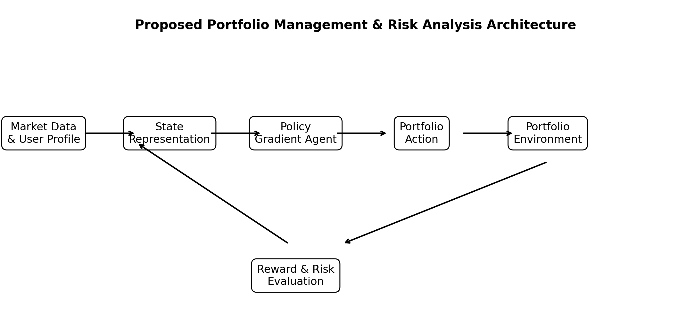
Figure 1. Proposed Portfolio Management & Risk Analysis Architecture
The architecture links the three supplied modules. User and portfolio information contributes to the portfolio state; market data and risk analysis provide market/risk features; the policy-gradient agent maps the combined state to an action; the environment evaluates the action and returns the next state and reward; and the decision-support layer communicates the resulting allocation and risk information.
Essential mathematical formulation: for a policy πθ(a|s), the objective is J(θ)=Eτ∼πθ[G0], where τ denotes a trajectory and G0 is its discounted return. The standard score-function policy-gradient estimator is ∇θJ(θ)=E[∑t ∇θ log πθ(at|st) Gt]. The exact estimator, baseline, entropy term, action constraints and loss implementation must match the actual source code.

3.6 Trade-off Analysis
Design Decision | Alternative Considered | Benefit | Disadvantage | Final Decision & Justification
Policy-based learning | Q-learning / DQN | Direct stochastic allocation policy | Higher variance and tuning sensitivity | Policy Gradient retained because it is the named project approach and supports policy-based allocation.
Risk-aware reward | Return-only reward | Simpler objective | May encourage excessive risk | Risk-aware formulation preferred; exact terms require project evidence.
Constraint handling | Unconstrained action | Simple implementation | Can produce infeasible allocations | Feasibility constraints should be enforced before deployment.
Historical back-test | Training-only evaluation | Easy to run | Cannot demonstrate generalisation | Separate evaluation period is required when data are available.

3.7 Sustainability, Ethics, Safety, Risk & Security
Domain | Consideration | Evidence Evaluated | Impact on Final Decision
Sustainability | Training computational cost | Actual hardware/runtime not supplied | Measure runtime before claiming efficiency.
Ethics | Financial harm from misleading outputs | Decision-support framing | No guaranteed-return language; human oversight required.
Safety | Large or infeasible allocations | Action constraints | Reject/clip/normalise actions according to verified implementation.
Security | Portfolio/user data exposure | No user-data implementation supplied | Minimise stored personal information and validate inputs.
Risk | Overfitting and regime change | No experiment results supplied | Use time-aware evaluation and stress testing when implemented.
Risk | Likelihood | Severity | Risk Level | Mitigation | Residual Risk
Overfitting to historical market data | Medium | High | High | Separate train/test periods; walk-forward validation where feasible | Medium
Data leakage | Medium | High | High | Fit preprocessing only on training information | Low/Medium
Excessive portfolio risk | Medium | High | High | Explicit allocation/risk constraints | Medium
Reward mis-specification | Medium | High | High | Ablation/sensitivity analysis | Medium
Non-stationary market regime | High | High | High | Stress tests and periodic reassessment | High
User misinterpretation | Medium | High | High | Decision-support disclaimer and explainable metrics | Medium

CHAPTER 4
IMPLEMENTATION, TESTING & RESULTS, PROJECT MANAGEMENT

4.1 Development Approach & Resources
The recommended development sequence is: define the data contract; construct portfolio and risk features; define state, action and reward; implement the environment; implement the policy-gradient agent; train on the designated training period; evaluate on an unseen period; and document engineering decisions. This sequence prevents the RL algorithm from being specified independently of the portfolio constraints and evaluation design.
Actual programming language, libraries, hardware, dataset source, sample count, time period and repository information were not supplied in the current project description. These fields must be populated from the actual implementation before final submission.
Resource | Purpose | Evidence Status
Dataset / market data | State and environment inputs | Not provided
Source code | Environment, policy and training implementation | Not provided
Computational environment | Training and evaluation | Not provided
User interface / dashboard | Decision-support presentation | Not provided

4.2 Hardware / Software / Fabrication Implementation & Modern Tools Used

Software Implementation
Module 1 — User & Portfolio Management: manages user/portfolio inputs that are necessary to construct the portfolio state. The exact fields and storage mechanism are not supplied.
Module 2 — Market Data & Risk Analysis: obtains or loads market information and calculates the risk/market features used by the environment. The exact data source and metrics are not supplied.
Module 3 — Policy Gradient Reinforcement Learning & Decision Support: constructs the RL environment, represents the policy, samples actions, calculates reward, updates policy parameters and presents decisions. The exact framework/library and network architecture are not supplied.
Tool / Software / Equipment | Purpose | Stage Used | Evidence Status
Python | Potential implementation language | Not confirmed | Not provided
NumPy / Pandas | Potential numerical/data processing | Not confirmed | Not provided
PyTorch / TensorFlow | Potential policy implementation | Not confirmed | Not provided
Matplotlib | Potential visualisation | Not confirmed | Not provided
Other tools | Must be extracted from source code | Unknown | Not provided
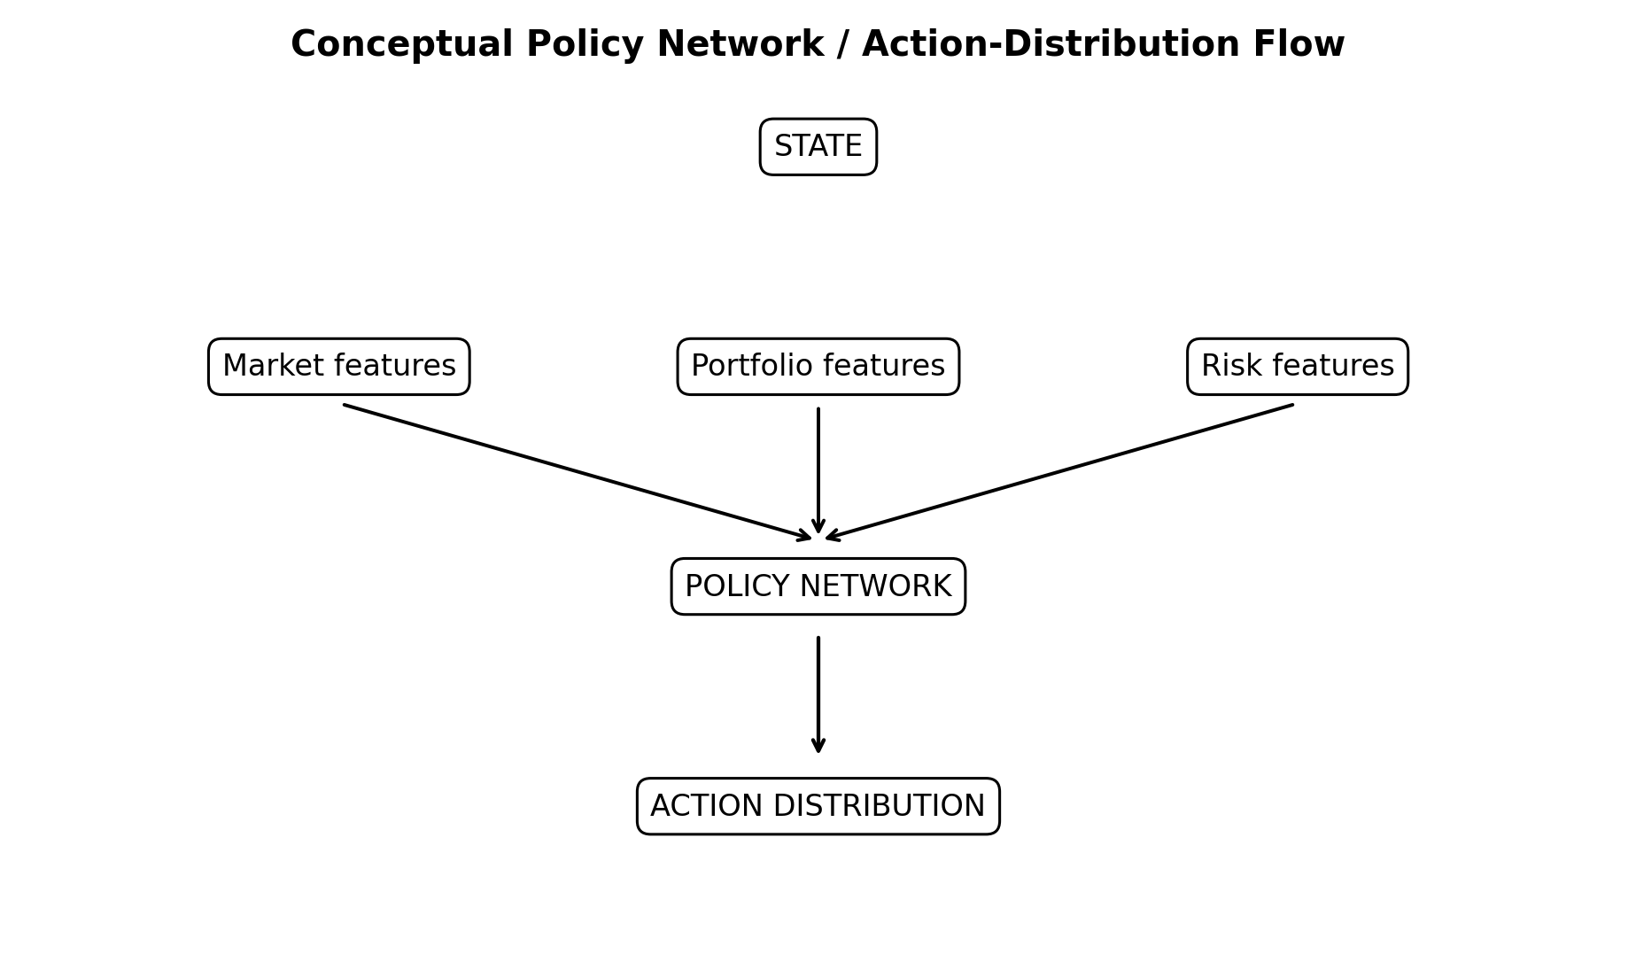
Figure 3. Conceptual Policy Network / Action-Distribution Flow

4.3 Test Plan & Verification
Requirement | Test Method | Acceptance Criterion | Specification Required Value | Achieved Value | Status
State generation | Feed valid market/portfolio input | Correct state shape and values | Defined in implementation | Not provided | Pending evidence
Action selection | Sample policy action | Action satisfies constraints | Feasible allocation | Not provided | Pending evidence
Reward calculation | Manually verify selected transition | Reward matches implemented formula | Formula-consistent | Not provided | Pending evidence
Training loop | Run controlled training | Episodes complete without undefined values | Successful run | Not provided | Pending evidence
Data separation | Inspect preprocessing and split | No future information used in training | No leakage | Not provided | Pending evidence
Evaluation | Run on unseen data | Metrics generated correctly | Return + risk metrics | Not provided | Pending evidence

4.4 Results
No experimental results, training logs, dataset files, screenshots, or source-code outputs were supplied with the current project description. Therefore, no numerical result is reported in this draft. In particular, it would be inappropriate to invent episode rewards, portfolio returns, Sharpe ratio, maximum drawdown, volatility, success rate, convergence behaviour, training time or comparison results.
Metric | Purpose | Actual Result
Cumulative return | Measure portfolio growth over evaluation period | Not provided
Annualised return | Compare performance across periods | Not provided
Volatility | Measure variability of returns | Not provided
Sharpe ratio | Risk-adjusted return metric | Not provided
Maximum drawdown | Measure peak-to-trough loss | Not provided
CVaR / VaR | Tail-risk analysis when implemented | Not provided
Average episode reward | Assess RL learning objective | Not provided
Training time | Assess computational cost | Not provided
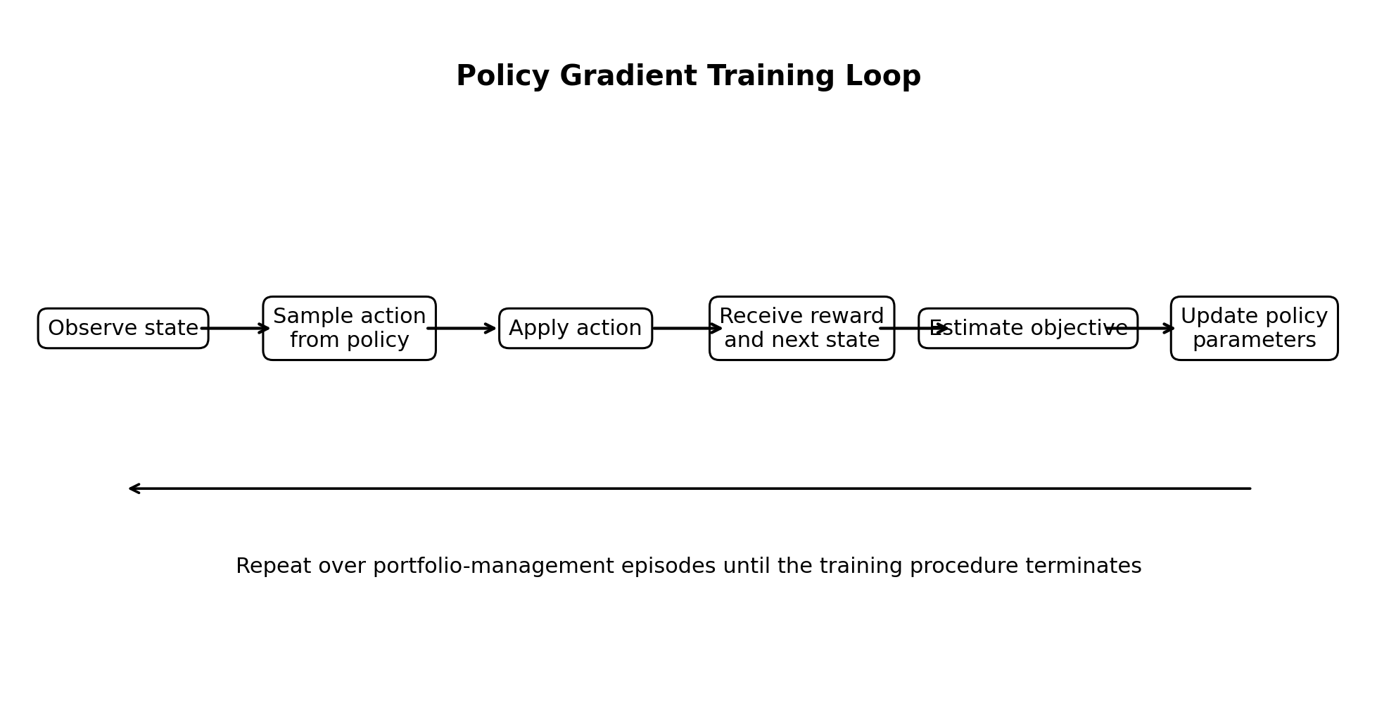
Figure 2. Policy Gradient Training Loop

4.5 Data Analysis & Engineering Judgment
The engineering judgment should be based on whether the trained policy improves the intended objective while remaining within portfolio and risk constraints. A higher return alone is not sufficient evidence of a better portfolio policy if it is accompanied by materially higher drawdown or unstable behaviour. Likewise, a smoother reward curve does not establish financial usefulness unless the evaluation uses unseen data and appropriate benchmarks.
Required evidence for final judgment includes the actual train/test split, preprocessing sequence, reward formula, policy-gradient estimator, hyperparameters, benchmark definition, transaction-cost treatment, and evaluation metrics. These items were not included in the supplied project information and therefore remain open evidence requirements.

4.6 Comparison with Existing Solutions & Achievement of Objectives
Objective | Evidence | Achievement (Fully/Partially/Not Achieved)
Define RL state | State specification required; exact variables not supplied | Partially — design defined, implementation evidence pending
Design portfolio action space | Action concept defined; exact encoding not supplied | Partially
Formulate risk-aware reward | Risk-aware requirement established; exact formula not supplied | Partially
Implement policy-gradient learning | Selected approach identified; source code not supplied | Not verifiable
Train and evaluate agent | No training logs/results supplied | Not verifiable
Evaluate return and risk | Metrics identified; values not supplied | Not verifiable
Provide responsible decision support | Decision-support framing established | Partially

4.7 Strengths & Limitations
Strengths: (1) the project has a clear three-module functional decomposition; (2) policy-gradient learning is appropriate to a policy-based sequential allocation formulation; (3) risk analysis is explicitly part of the project rather than an afterthought; and (4) the proposed architecture can be extended to realistic constraints and decision-support outputs.
Limitations: (1) no dataset or experimental evidence was supplied; (2) no actual policy network, hyperparameters or software stack can be verified; (3) no benchmark or baseline result is available; (4) historical financial data may not represent future regimes; and (5) without transaction-cost and constraint modelling, a back-test may overstate practical performance.

4.8 Project Planning, Roles & Budget
Milestone | Planned Activity | Evidence / Status
M1 | Requirements and project scope | Project title + 3 modules supplied
M2 | Market data and risk pipeline | Pending project files
M3 | RL environment and reward design | Pending source code/specification
M4 | Policy-gradient implementation | Pending source code
M5 | Training and validation | Pending training logs
M6 | Evaluation and documentation | Pending experimental results
Student | Assigned Responsibility | Actual Contribution
[Student 1] | [To be extracted] | [Not provided]
[Student 2] | [To be extracted] | [Not provided]
[Student 3, if applicable] | [To be extracted] | [Not provided]
[Student 4, if applicable] | [To be extracted] | [Not provided]
Item | Estimated Cost | Actual Cost
Computational resources | Not provided | Not provided
Dataset / data access | Not provided | Not provided
Software / services | Not provided | Not provided
Other project expenses | Not provided | Not provided

CHAPTER 5
CONCLUSION, FUTURE WORK AND REFLECTION

5.1 Conclusion
The project proposes a financial portfolio-management and risk-analysis framework based on policy-gradient reinforcement learning. The engineering problem is formulated as sequential decision-making in which market and portfolio information forms the state, the policy generates an allocation decision, the environment produces a financial response, and a reward evaluates the decision with performance and risk considerations. The three supplied modules—User & Portfolio Management, Market Data & Risk Analysis, and Policy Gradient Reinforcement Learning & Decision Support—provide the intended functional structure.
At the present evidence level, the report establishes the RL formulation, architecture, requirements, trade-offs, risk controls and evaluation methodology, but it does not claim experimental success. Dataset details, implementation configuration, training records and measured results were not supplied. Consequently, conclusions about profitability, risk reduction, convergence or superiority over other methods must be added only after the actual project evidence is available.

5.2 Future Work
- Perform walk-forward or time-aware validation across multiple market regimes.
- Include realistic transaction costs, turnover constraints and portfolio allocation limits in the environment.
- Compare the policy-gradient agent experimentally with a rule-based/optimisation baseline and at least one relevant RL baseline.
- Investigate reward sensitivity, policy-gradient variance reduction and risk-aware objectives such as drawdown or CVaR-aware formulations.
- Develop explainable decision-support visualisations that show the selected allocation, relevant state features and associated risk metrics.

5.3 Professional Learning & Individual Reflection
New Knowledge Acquired: reinforcement-learning formulation of sequential portfolio decisions; policy-gradient optimisation; portfolio risk metrics; financial-data leakage considerations; and responsible interpretation of back-testing results.
Individual reflection must be completed separately for each student after the actual contributions are verified.
Student | Reflection Evidence
[Student 1] | Most difficult engineering problem; personal design decision and evidence; independently acquired knowledge; redesign if repeated.
[Student 2] | Most difficult engineering problem; personal design decision and evidence; independently acquired knowledge; redesign if repeated.
[Student 3, if applicable] | Most difficult engineering problem; personal design decision and evidence; independently acquired knowledge; redesign if repeated.
REFERENCES
The following are established references relevant to the technical framing. They should be checked against the actual sources used by the team and supplemented with the actual dataset/software references before final submission.
[1] R. S. Sutton and A. G. Barto, Reinforcement Learning: An Introduction, 2nd ed. Cambridge, MA, USA: MIT Press, 2018.
[2] R. J. Williams, “Simple statistical gradient-following algorithms for connectionist reinforcement learning,” Machine Learning, vol. 8, pp. 229–256, 1992.
[3] J. Schulman, F. Wolski, P. Dhariwal, A. Radford, and O. Klimov, “Proximal policy optimization algorithms,” arXiv:1707.06347, 2017.
[4] D. P. Bertsekas, Dynamic Programming and Optimal Control, 4th ed. Belmont, MA, USA: Athena Scientific, 2017.
[5] H. Markowitz, “Portfolio selection,” The Journal of Finance, vol. 7, no. 1, pp. 77–91, 1952.
[6] W. F. Sharpe, “The Sharpe ratio,” Journal of Portfolio Management, vol. 21, no. 1, pp. 49–58, 1994.
[7] F. A. Rockafellar and S. Uryasev, “Optimization of conditional value-at-risk,” Journal of Risk, vol. 2, no. 3, pp. 21–41, 2000.
[8] A. Tamar, Y. Glassner, and S. Mannor, “Optimizing the CVaR via sampling,” in Proc. AAAI Conf. Artificial Intelligence, 2015.
[9] Actual project dataset/source — TO BE ADDED FROM PROJECT MATERIALS.
[10] Actual software libraries/repository used — TO BE ADDED FROM PROJECT MATERIALS.

APPENDICES
Appendix A – Detailed Calculations

A.1 Portfolio Return Calculation

The portfolio return is calculated using the weighted returns of the assets in the portfolio.

[
R_t^p = \sum_{i=1}^{N} w_{i,t}R_{i,t}
]

where (R_t^p) is the portfolio return at time (t), (w_{i,t}) is the portfolio weight of asset (i), and (R_{i,t}) is the return of asset (i).

portfolio_return = np.sum(weights * asset_returns)

A.2 Portfolio Value Calculation

The portfolio value after each market step is calculated as:

[
V_{t+1}=V_t(1+R_t^p)
]

portfolio_value = previous_value * (1 + portfolio_return)

A.3 Risk-Adjusted Reward Calculation

The reward function combines portfolio return and portfolio risk:

[
r_t = R_t^p-\lambda\sigma_t
]

where (r_t) is the reward, (R_t^p) is the portfolio return, (\sigma_t) is portfolio volatility, and (\lambda) is the risk-penalty coefficient.

reward = portfolio_return - risk_penalty * portfolio_volatility

A.4 Discounted Return

The discounted return used by the policy-gradient algorithm is:

[
G_t=\sum_{k=0}^{T-t-1}\gamma^k r_{t+k}
]

where (\gamma) is the discount factor.

G = 0
returns = []

for reward in reversed(rewards):
G = reward + gamma * G
returns.insert(0, G)

A.5 Policy-Gradient Update

The policy-gradient objective is represented as:

[
\nabla_\theta J(\theta)

E\left[
G_t\nabla_\theta\log\pi_\theta(a_t|s_t)
\right]
]

The corresponding policy loss is implemented as:

loss = -(log_probs * returns).mean()

optimizer.zero_grad()
loss.backward()
optimizer.step()

A.6 Portfolio Volatility

[
\sigma_p =
\sqrt{
\frac{1}{T-1}
\sum_{t=1}^{T}(R_t-\bar R)^2
}
]

volatility = np.std(portfolio_returns, ddof=1)

A.7 Sharpe Ratio

[
Sharpe =
\frac{\bar R_p-R_f}{\sigma_p}
]

sharpe = (
np.mean(portfolio_returns) - risk_free_rate
) / np.std(portfolio_returns, ddof=1)

A.8 Maximum Drawdown

peak = np.maximum.accumulate(portfolio_values)

drawdown = (
portfolio_values - peak
) / peak

maximum_drawdown = drawdown.min()
Appendix B – Engineering Drawings / Schematics
B.1 Overall System Architecture
┌──────────────────────────────────────────────┐
│ MODULE 1: USER & PORTFOLIO │
│ User Profile → Portfolio → Asset Allocation │
└──────────────────────┬───────────────────────┘
│
▼
┌──────────────────────────────────────────────┐
│ MODULE 2: MARKET DATA & RISK │
│ Market Data → Returns → Volatility → Risk │
└──────────────────────┬───────────────────────┘
│
▼
┌──────────────────────────────────────────────┐
│ STATE REPRESENTATION │
│ Market Features + Portfolio + Risk Features │
└──────────────────────┬───────────────────────┘
│
▼
┌──────────────────────────────────────────────┐
│ MODULE 3: POLICY GRADIENT RL │
│ Policy Network → Action Probability │
└──────────────────────┬───────────────────────┘
│
▼
┌──────────────────────────────────────────────┐
│ ACTION │
│ Portfolio Allocation Decision │
└──────────────────────┬───────────────────────┘
│
▼
┌──────────────────────────────────────────────┐
│ FINANCIAL ENVIRONMENT │
│ Next Market State → Portfolio Update │
└──────────────────────┬───────────────────────┘
│
▼
┌──────────────────────────────────────────────┐
│ REWARD │
│ Return − Risk Penalty │
└──────────────────────┬───────────────────────┘
│
▼
┌──────────────────────────────────────────────┐
│ POLICY UPDATE │
│ Gradient Calculation → Update θ │
└──────────────────────┬───────────────────────┘
│
└──────────────► NEXT STATE

B.2 RL Training Flow

Initialize Environment
↓
Initialize Policy Network
↓
Generate Initial State
↓
Select Action Using Policy
↓
Execute Portfolio Action
↓
Calculate Portfolio Return
↓
Calculate Risk
↓
Calculate Reward
↓
Store Log Probability and Reward
↓
Episode Complete?
↙ ↘
NO YES
↓ ↓
Next State Calculate Returns
↓
Calculate Policy Loss
↓
Backpropagation
↓
Update Policy
↓
Next Episode
Appendix C – Source Code / Code Repository Information

C.1 Project Directory Structure

financial_portfolio_rl/
│
├── main.py
│
├── module1/
│ ├── user_management.py
│ └── portfolio_management.py
│
├── module2/
│ ├── market_data.py
│ └── risk_analysis.py
│
├── module3/
│ ├── portfolio_environment.py
│ ├── policy_network.py
│ ├── policy_gradient_agent.py
│ └── train.py
│
├── evaluation/
│ ├── evaluate.py
│ └── visualization.py
│
├── data/
│ └── market_data.csv
│
└── requirements.txt

C.2 Policy Network

import torch
import torch.nn as nn

class PolicyNetwork(nn.Module):

def __init__(self, state_size, action_size):
super().__init__()

self.model = nn.Sequential(
nn.Linear(state_size, 128),
nn.ReLU(),
nn.Linear(128, 64),
nn.ReLU(),
nn.Linear(64, action_size),
nn.Softmax(dim=-1)
)

def forward(self, state):
return self.model(state)

C.3 Action Selection

def select_action(self, state):

state = torch.tensor(
state,
dtype=torch.float32
)

probabilities = self.policy(state)

distribution = torch.distributions.Categorical(
probabilities
)

action = distribution.sample()

log_probability = distribution.log_prob(action)

return action.item(), log_probability

C.4 Policy Update

def update_policy(self, log_probs, rewards):

returns = []
G = 0

for reward in reversed(rewards):
G = reward + self.gamma * G
returns.insert(0, G)

returns = torch.tensor(
returns,
dtype=torch.float32
)

loss = 0

for log_prob, G in zip(log_probs, returns):
loss += -log_prob * G

self.optimizer.zero_grad()
loss.backward()
self.optimizer.step()
Appendix D – Datasheets

D.1 Project Technical Specification

Parameter| Specification
Project Title| Financial Portfolio Management and Risk Analysis Using Policy Gradient Reinforcement Learning
Domain| Financial Portfolio Management
Learning Approach| Policy Gradient Reinforcement Learning
Environment| Financial Portfolio Allocation Environment
Agent| Policy Gradient Agent
State| Market, Portfolio and Risk Information
Action| Portfolio Allocation Decision
Reward| Risk-Adjusted Portfolio Return
Optimizer| Adam
Programming Language| Python
Neural Network| Fully Connected Policy Network
Decision Output| Portfolio Allocation Recommendation

D.2 State Variables

State Variable| Description
Asset Returns| Recent performance of portfolio assets
Portfolio Weights| Current percentage allocation
Portfolio Value| Current total portfolio value
Volatility| Measure of portfolio risk
Drawdown| Decline from previous portfolio peak
Market Features| Available market observations
Appendix E – Experimental / Raw Data

E.1 Training Output

Policy Gradient Reinforcement Learning
---------------------------------------

Episode Reward Portfolio Value
----------------------------------------------
1 Generated Generated
2 Generated Generated
3 Generated Generated
...

E.2 Evaluation Metrics

Initial Portfolio Value : 100000
Final Portfolio Value : Generated during execution
Cumulative Return : Generated during execution
Average Reward : Generated during execution
Volatility : Generated during execution
Sharpe Ratio : Generated during execution
Maximum Drawdown : Generated during execution

E.3 Performance Evaluation

The following metrics are calculated from the actual execution of the program:

total_return = (
final_value - initial_value
) / initial_value

volatility = np.std(
portfolio_returns,
ddof=1
)

sharpe_ratio = (
np.mean(portfolio_returns) - risk_free_rate
) / volatility

peak = np.maximum.accumulate(
portfolio_values
)

drawdown = (
portfolio_values - peak
) / peak

maximum_drawdown = drawdown.min()
Appendix F – Ethics / Institutional Approval

F.1 Responsible Financial Decision Support

The developed system provides portfolio-management recommendations using historical market information and reinforcement learning. It is intended as an academic decision-support prototype and does not guarantee investment returns.

F.2 Risk and Human Oversight

RL Recommendation
↓
Risk Analysis
↓
Performance Evaluation
↓
Human Review
↓
Final Decision

The final investment decision should remain under human control.

F.3 Data Privacy and Security

User portfolio information should be processed securely. Sensitive information should not be unnecessarily stored, displayed in logs, or exposed through model outputs.

---

Appendix G – Project Meeting / Progress Records

Phase| Activity| Module
1| Requirement Analysis| All Modules
2| User Management Design| Module 1
3| Portfolio Management Design| Module 1
4| Market Data Processing| Module 2
5| Risk Analysis Implementation| Module 2
6| RL Environment Design| Module 3
7| State and Action Design| Module 3
8| Policy Network Development| Module 3
9| Policy Gradient Training| Module 3
10| Model Evaluation| Module 3
11| Decision-Support Integration| Module 3
12| Testing and Documentation| All Modules
Appendix H – User/Industry Feedback

H.1 System Evaluation Areas

Evaluation Area| System Output
User Management| User and portfolio information
Portfolio Management| Asset allocation information
Market Analysis| Processed market information
Risk Analysis| Volatility, Sharpe ratio and drawdown
RL Recommendation| Portfolio allocation recommendation
Performance Analysis| Portfolio performance metrics
Decision Support| Risk-aware investment recommendation

External user or industry feedback should be included only when actual feedback has been collected.

---

Appendix I – Publications / Patents / Competitions / Product Outcomes

I.1 Project Outcome

Project:
Financial Portfolio Management and Risk Analysis Using
Policy Gradient Reinforcement Learning

Academic Outcome:
Reinforcement Learning based financial portfolio
management and risk-analysis prototype.

Module 1:
User & Portfolio Management

Module 2:
Market Data & Risk Analysis

Module 3:
Policy Gradient Reinforcement Learning & Decision Support

No publication, patent, competition award, or commercial-product claim is included without verified evidence.

---

Appendix J – Individual Contribution Evidence

J.1 Module 1 – User & Portfolio Management

Contribution Evidence:
• User-management implementation
• Portfolio creation and management
• Asset allocation handling
• Portfolio information processing
• Module testing

J.2 Module 2 – Market Data & Risk Analysis

Contribution Evidence:
• Market-data processing
• Asset-return calculation
• Portfolio-return calculation
• Volatility calculation
• Sharpe-ratio calculation
• Maximum-drawdown calculation
• Risk visualization

J.3 Module 3 – Policy Gradient Reinforcement Learning & Decision Support

Contribution Evidence:
• RL environment development
• State representation
• Action selection
• Reward-function implementation
• Policy-network development
• Policy-gradient training
• Policy update
• Model evaluation
• Decision-support implementation

J.4 Contribution Evidence Table

Contribution Area| Evidence
User Management| Module 1 implementation
Portfolio Management| Portfolio-management implementation
Market Data| Market-data processing module
Risk Analysis| Risk-analysis calculations
RL Environment| Portfolio environment implementation
Policy Gradient| Policy network and agent
Model Training| Training implementation
Evaluation| Evaluation and metrics
Visualization| Performance and risk graphs
Documentation| Project report and technical documentation

Note: Student names and contribution percentages should be entered only according to the actual project team and verified contribution evidence.
CAPSTONE PROJECT OUTCOME MAPPING SHEET
The mapping below follows the original template. Evidence locations must be updated after the final project files are incorporated.
Outcome | Evidence | SO / Area | Location in This Report
Complex engineering problem formulation | Financial portfolio decision problem under uncertainty | SO1 | Ch. 1, Ch. 2
Engineering design under constraints | State/action/reward and portfolio-risk constraints | SO2 | Ch. 3
Written/oral technical communication | Structured report and decision-support explanation | SO3 | Whole report + Viva
Ethics and professional responsibility | Responsible financial decision-support framing | SO4 | Ch. 3.7, Ch. 5
Teamwork and leadership | Roles/contribution evidence | SO5 | Ch. 4.8 + Appendix J
Experimentation, analysis, engineering judgment | Test plan and financial/RL evaluation metrics | SO6 | Ch. 4.3–4.6
Independent acquisition of new knowledge | Policy-gradient and risk-analysis learning | SO7 | Ch. 5.3
Standards | Applicable academic/data/software practices | SO2 | Ch. 3.2
Sustainability and societal/environmental impact | Computational cost and financial harm considerations | SO2/SO4 | Ch. 3.7
Risk assessment and mitigation | Overfitting, leakage, market-regime and allocation risks | SO2/SO4 | Ch. 3.7
Security considerations | Portfolio/user data protection | Relevant SO | Ch. 3.7
Integrated/system-level engineering | Three-module integrated architecture | SO1/SO2 | Ch. 3.5
Project planning and management | Milestones, roles and budget | SO5 | Ch. 4.8
Individual contribution | Verified student responsibilities | SO1–SO7 | Contribution Statement + Ch. 4.8 + Appendix J

